1)

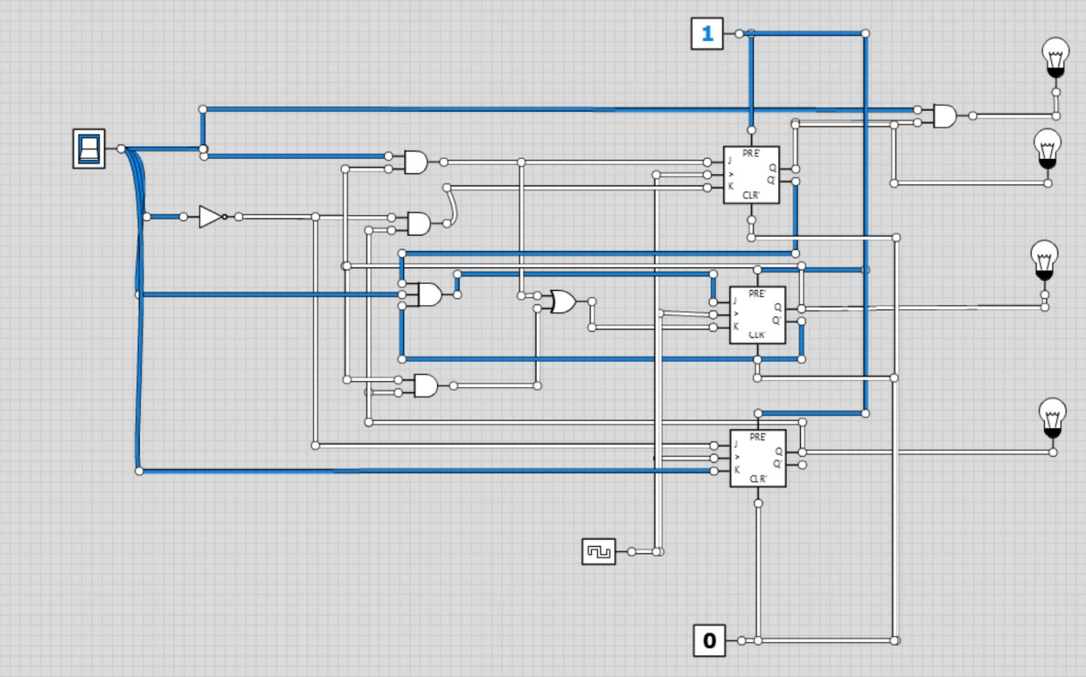

For this circuit the output is consistently 0 for all inputs

2)

Below is my circuit and the different states it was in as the shift register progressed

Default state

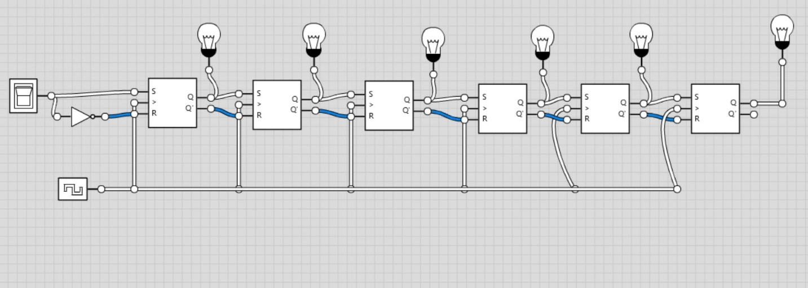

101011

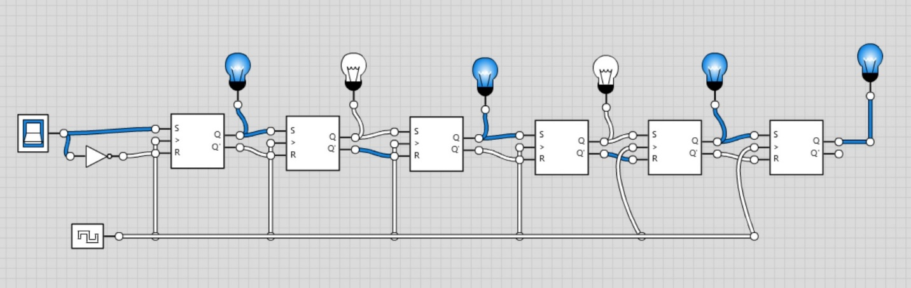

010101

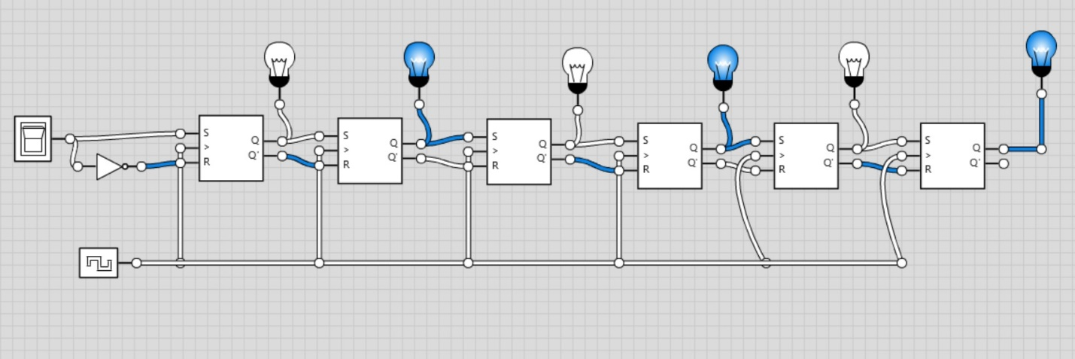

001010

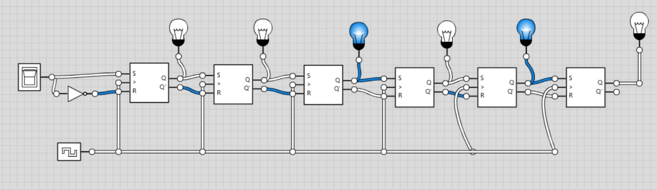

000101

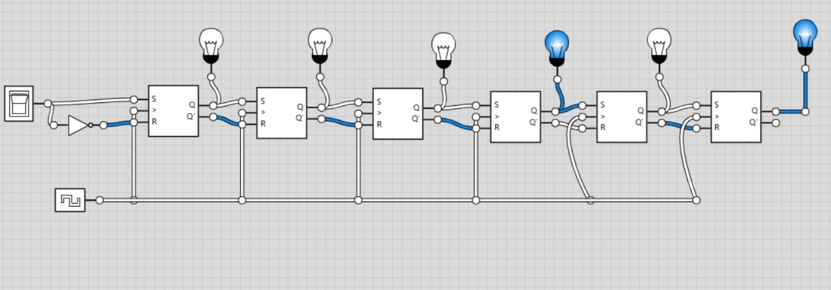

000010

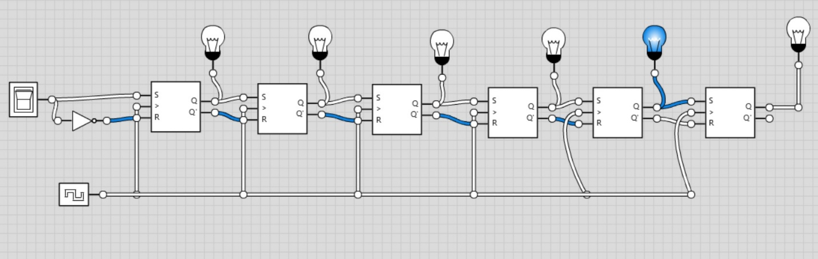

000001

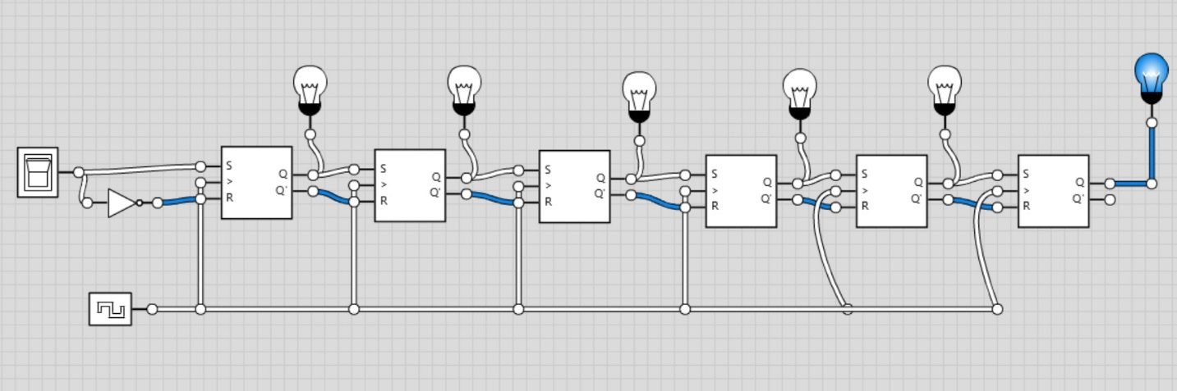

000000

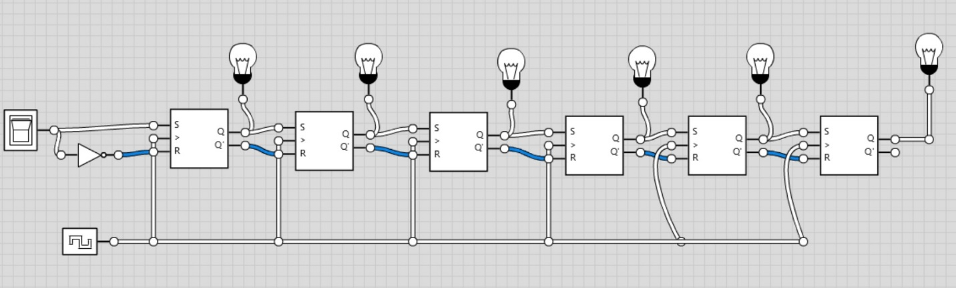

Paper work:

